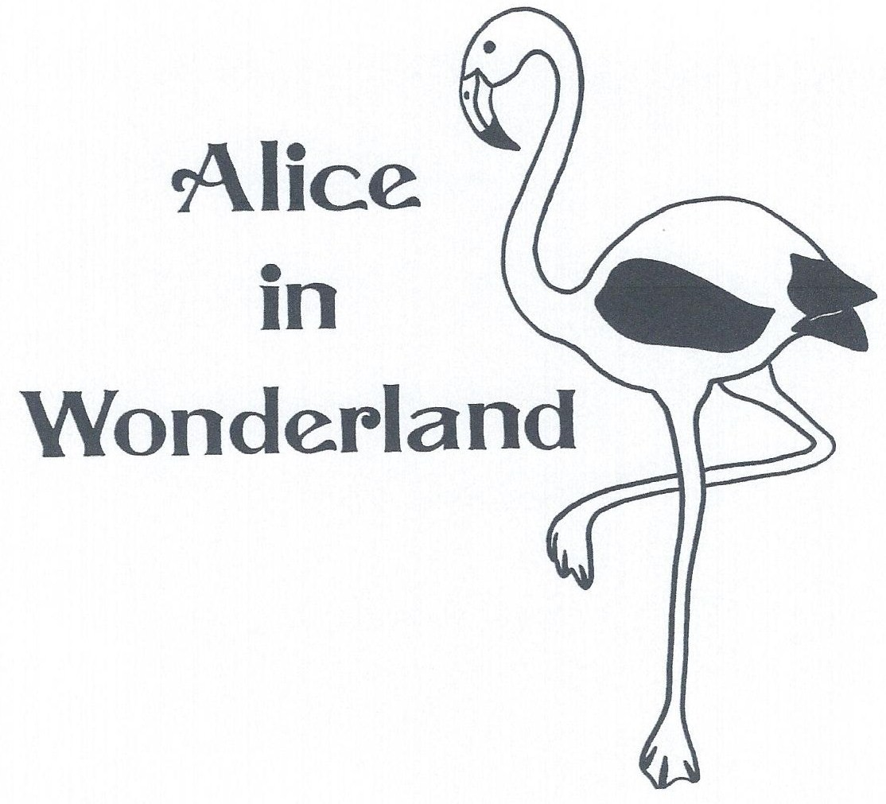
FOR IMMEDIATE RELEASE

Date: __________________________

PERFORMANCES SCHEDULED FOR PRAIRIE FIRE
CHILDREN’S THEATRE’S
“ALICE IN WONDERLAND”

(Your community) - Check your watch and don’t be late! You have a very important date this weekend with (# in cast) local children and two professional actors as they take the stage in Prairie Fire Children’s Theatre’s original musical version of ALICE IN WONDERLAND!

“ALICE,” with original script and music by Daniel Nordquist, and set and costume design by Deborah Pick, continues Prairie Fire’s tradition of presenting classic tales as you’ve never seen them done before. The local cast features: (attach cast list)

Prairie Fire Theatre professionals (insert actor name/bio) and (insert actor name/bio) will co-direct and play the roles of The Queen of Hearts and The Mad Hatter.

“Alice in Wonderland” is the culmination of a week long residency by Prairie Fire Children’s Theatre and is sponsored by (sponsor) . Performances are on (time, day of the week, and date) at (location) .

Tickets are (price) and are available at (location) . For more information,
call (sponsor’s phone number) .
