Prairie Fire Children’s Theatre  Founded in 1987, Prairie Fire tours year-round to over 200 communities providing a week-long professional theatrical experience. Prairie Fire not only specializes in touring original adaptations of classic children’s tales, but also has a touring program for junior and high schools. In addition, Prairie Fire is available for theatrical workshops residencies. Prairie Fire is a proud recipient of the Minnesota Alliance of the Arts in Educational Programming.  For more information, contact:  Box 82, Barrett, MN 56311  Or (320) 528-2596  www.prairiefirechildrenstheatre.com  Acknowledgements  (An Opportunity for Thank You’s)  *No flash photos during performances, please!*  A photo session will follow each performance.  Thank you! |  |  | 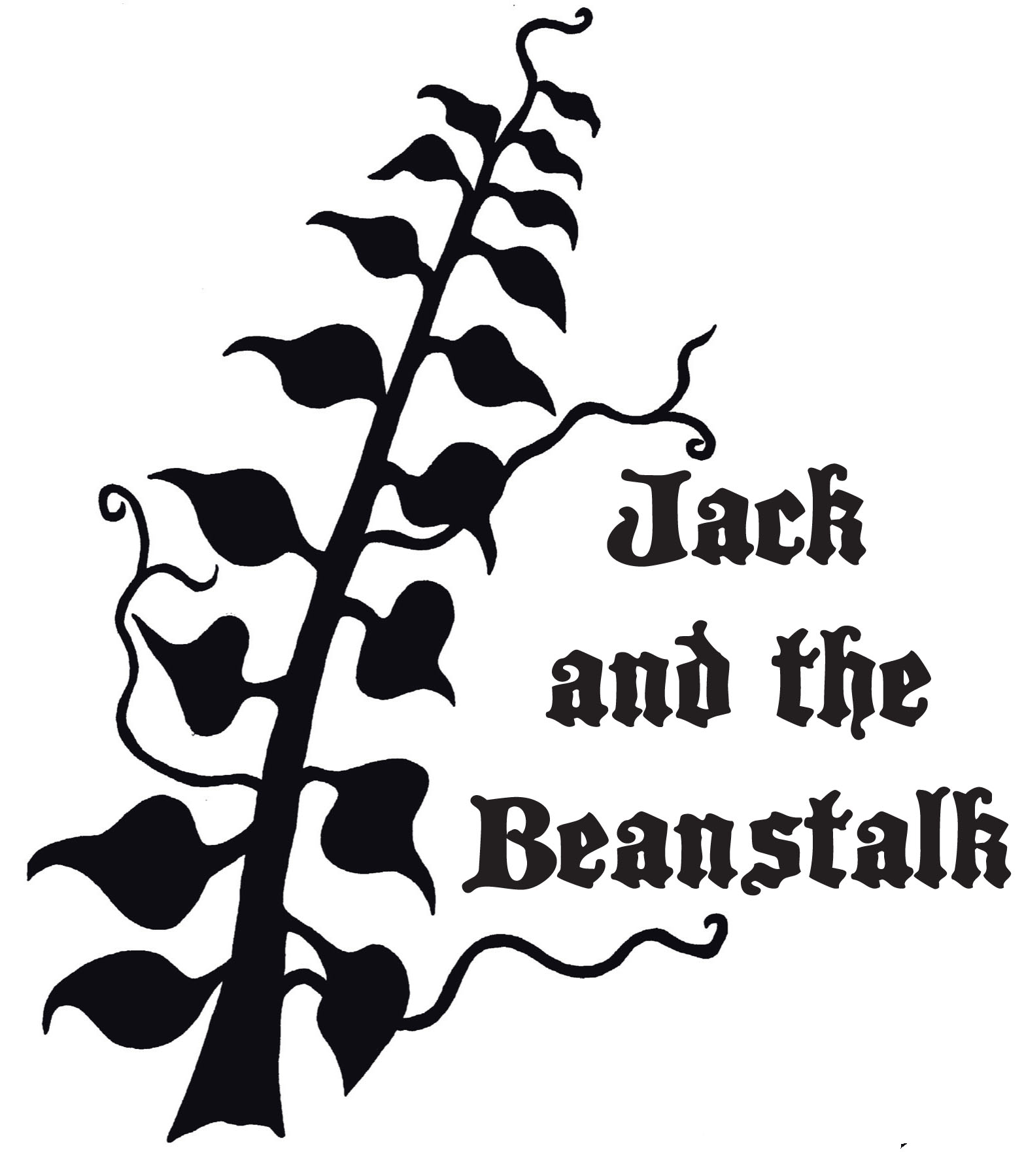  Script by Bob Gribas and Original Music by Angela Rinaldi  (Performance time(s), date(s) and location)  Prairie Fire Children’s Theatre  and  (Sponsoring Organization)  Present

The Cast  Jack  Jessie  Mother  Old Jeb  Enoch Slumlord  Percy  Prissy  Sally  Gabby  Toby  Villager  Villager  Lucia / Storyteller *  Giant / Ringmaster *  Milky  Princess Harp  Goose  Carnies  Bobo  Coco  Carnies -  Orchestranians  King Harmony  Queen Melody  Bass  Treble  Major Minor  Horn of Plenty  Orchestranians –  *Indicates PFCT Actor/Director |  |  | Birds  Toucan  Turkey  Peacock  Owl  Birds -  Trolls  Troll Leader  Trolls –  The Scenes  Scene 1 …………………………….………….………………………………The Story  Scene 2 ……………………………….……………..……..………………The Village  Scene 3 …………………………….……………………………………..The Carnival  Scene 4 ………………………….……….……………………….The Magic Beans  Scene 5 ………………………..……………...………….The Ribbon in the Sky  Scene 6 ………………………………….……………..…………….…Orchestrania  Scene 7 …………………………………………………………...……….Featherville  Scene 8 …………………..…..………………….……………….Land of the Trolls  Scene 9 ……..………………………………………..……Return to Featherville  Scene 10 ….…………………….……...………….......Orchestrania Revisted  Scene 11 ………………………..……………………….…………......Home Again  Music Credits  Original songs by Bob Gribas & Angela Rinaldi Gribas  “Carnival”, “Four Worlds”, “Orchestrania”, “Birdwalk”, “What Are We Doing Here?”, “Lullaby”  Other  Madazulu by Deep Forest

