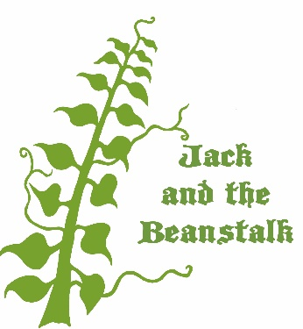
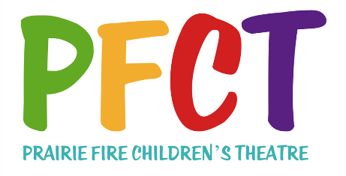

FOR IMMEDIATE RELEASE
DATE:
AUDITIONS SCHEDULED FOR
PRAIRIE FIRE CHILDREN’S THEATRE’S
“Jack and the Beanstalk”

(Community) – Auditions for Prairie Fire Children’s Theatre’s original musical production of “JACK AND THE BEANSTALK” will be held on (Day & Date) at (Time) at (Location) in (Community).
Up to 70 children (and adults if applicable) are needed to play the roles of JACK, HIS FELLOW VILLAGERS, THE CARNIVAL PERFORMERS, THE PEOPLE OF ORCHESTRANIA, THE INHABITANTS OF FEATHERVILLE, AND THE TROLLS.
Auditions are open to anyone age 7 through (Age). The audition process lasts up to two hours and all those auditioning are required to be in attendance for its entirety. The cast will be announced at the end of the two hour audition; each cast member will receive a rehearsal schedule for the remainder of the week. The cast will be required to stay following auditions for a short rehearsal.
Rehearsals will be held from (Time) to (Time) throughout the remainder of the week, with performance(s) scheduled for (Performance Day(s), Date(s), Time(s)) at (Location) in (Community).
Two professional actor/directors from the staff of Prairie Fire Children’s Theatre will direct the production and play the roles of THE STORYTELLER and THE GIANT.
This week long Prairie Fire Children’s Theatre residency is being sponsored by (Sponsor Organization)
This is Prairie Fire’s (Number) visit to (Community). Previous residencies were (Show Titles).
Tickets for the performance(s) are (Price) and are available at (Advance Outlet(s) and/or “At the Door”).
FOR MORE INFORMATION: (Sponsor Contact Name & Phone Number)

