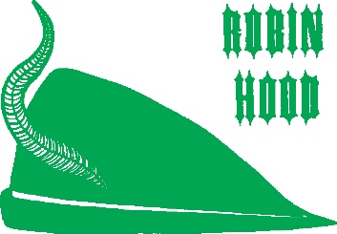
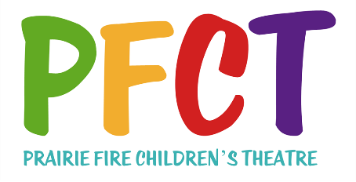
PRESS RELEASE – AUDITIONS
FOR IMMEDIATE RELEASE
Date:

“Robin Hood” AUDITIONS SLATED

(Your Community) – Auditions for Prairie Fire Children’s Theatre’s original musical production of “Robin Hood” will be held on (Day and Date) at (Location) in (Community).

Up to 84 young people (and adults if applicable) are needed to play the roles of: Robin Hood, Cook Henny, Little John, Friar Tuck, Will Scarlett, Maid Marian, her Tutors Ariel, Juliette, and Wilhelmina, Prince John, The Sheriff of Nottingham’s daughters Anabel and Jezebel, The Sheriff’s Deputies, Bluebell, Poppy, The Faeries, “Grunt” The King of the Gnomes, and Gnomes of Sherwood Forest.

Auditions are open to anyone age 7 through (Age). The Audition process last up to 2 hours and all those auditioning are required to be in attendance throughout its entirety. No preparation is necessary to audition. A portion of the cast will be required to stay following auditions for a shots rehearsal.

Rehearsals will be held from (time) to (time) the remainder of the week, with performance(s) scheduled for (date(s), time(s), and location) .

Two professional actor/directors from Prairie Fire Children’s Theatre’s staff will direct the production and play the roles of Flora, The Queen of the Faeries and The Sheriff of Nottingham.

Tickets for the performance(s) are (price) and are available at (the door or advance outlets)

This week-long Prairie Fire Children’s Theatre residency is sponsored by (Sponsoring Organization)

For more information, contact: (local contact and phone number).

