Prairie Fire Theatre
Founded in 1987, Prairie Fire tours year-round to over 200 communities providing a week-long professional theatrical experience. Prairie Fire not only specializes in touring original adaptations of classic children’s tales, but also has a touring program for junior and high schools. In addition, Prairie Fire is available for theatrical workshops residencies. Prairie Fire is a proud recipient of the Minnesota Alliance of the Arts in Educational Programming.

For more information, contact:
Box 82, Barrett, MN 56311
Or (320) 528-2596
prairiefirechildrenstheatre.com

Acknowledgements
(An Opportunity for Thank You’s)

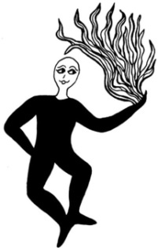
*No flash photos during
performances, please!
A photo session will follow
each performance.
Thank you!

Prairie Fire Children’s Theatre
and
(Sponsoring Organization)
Present
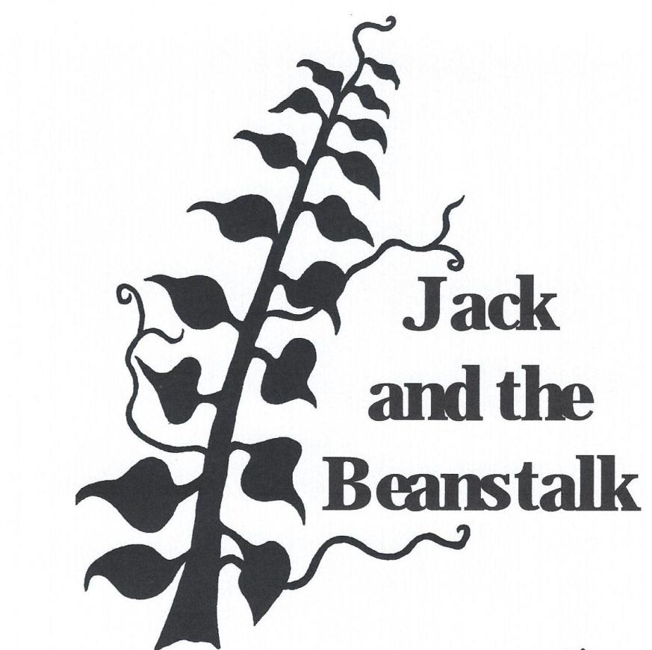
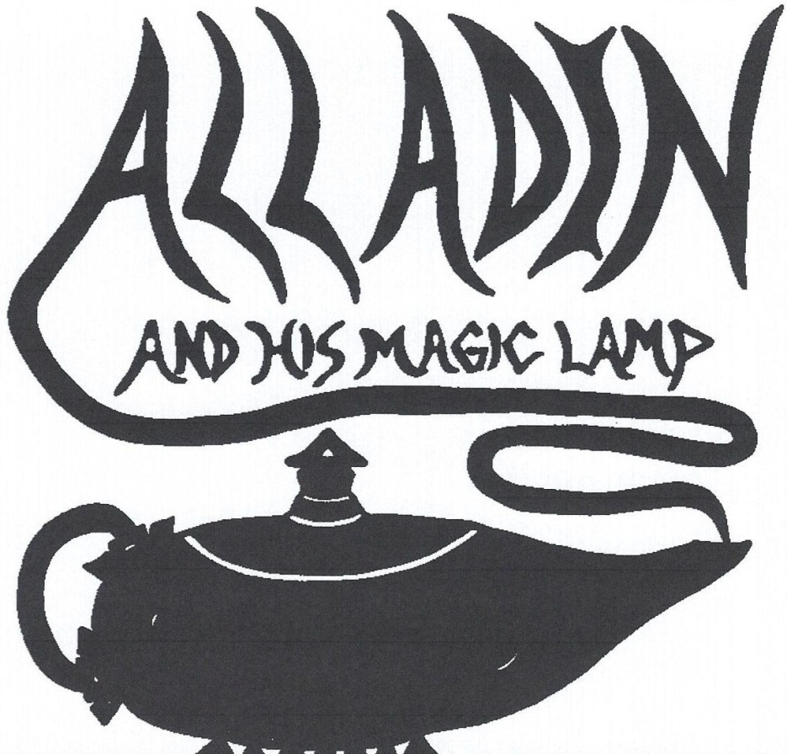

By Daniel Nordquist and Deborah Pick

(Performance time(s), date(s) and location)
The Cast

(Available from the directors after auditions)

The Scenes
Scene 1 …………………………….………………….……“Opening Chant”
Scene 2 ……………………………….……………..…………. “The Bazaar”
Scene 3 ………………………..…… “The Magician Meets Harmonia”
Scene 4 ………………………….………………..… “The Sultan’s Palace”
Scene 5 …………………………..………..………… “Taking the Day Off”
Scene 6 ………………………………….………………………...”The Stone”
Scene 7 …………………………..……………… “The Giant Gemstones”
Scene 8 …………………..…..……………….. “The Genie of the Lamp”
Scene 9 ……..………………..……. “Lounging With The Blueprints”
Scene 10 ….………………...………. “Another Poor Beggar Woman”
Scene 11 ………………………..……………….... “Wedding Procession”
Scene 12…………………..………………….… “The Palace is Finished”
Scene 13……………………..……………………... “Old Lamps for New”
Scene 14………………………..…… “Oh, What a Beautiful Morning”
Scene 15……………….………………. “The Ring Genie in the Desert”
Scene 16………………………………………………………… “The Rescue”
Scene 17……………………………………………………..…. “Where am I”
Scene 18…………………………….………………… “A Lesson Learned”

Musical Credits
Original song by Daniel Nordquist
“A Long Time Ago in a Land Far Away”
Original song by Deborah Nelson Pick
“I am the Genie of the Lamp”
Other
Don Ellis and his Orchestra, Blanc Mange, The Bangles, Various Middle Eastern Artists

