PRAIRIE FIRE CHILDREN’S THEATRE
and
(Sponsoring Organization)
PRESENT
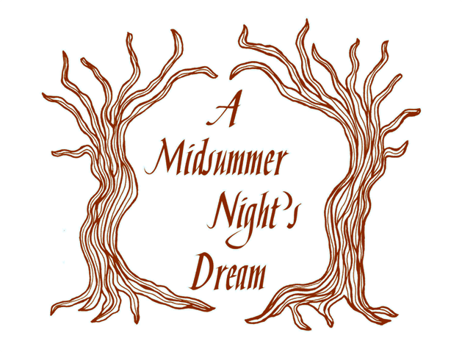
By William Shakespeare
Adapted by Ben Ratkowski and Deborah Nelson Pick
Music by Daniel Stock

At:

Dates:

Times:

Ticket Prices:

For More Information:

