PRAIRE FIRE CHILDREN’S THEATRE
and
(Sponsoring Organization)
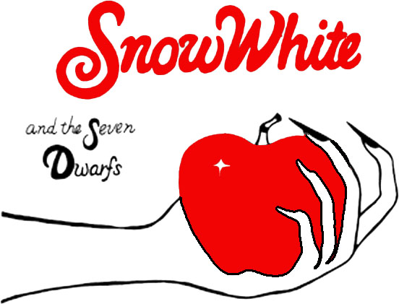
PRESENT

WHEN:
WHERE:
TICKETS:

