Prairie Fire Children’s Theatre  Founded in 1987, Prairie Fire tours year-round to over 200 communities providing a week-long professional theatrical experience. Prairie Fire not only specializes in touring original adaptations of classic children’s tales, but also has a touring program for junior and high schools. In addition, Prairie Fire is available for theatrical workshops residencies. Prairie Fire is a proud recipient of the Minnesota Alliance of the Arts in Educational Programming.  For more information, contact:  Box 82, Barrett, MN 56311  Or (320) 528-2596  www.prairiefirechildrenstheatre.com  Acknowledgements  (An Opportunity for Thank You’s)  *No flash photos during performances, please!*  A photo session will follow each performance.  Thank you! |  |  | 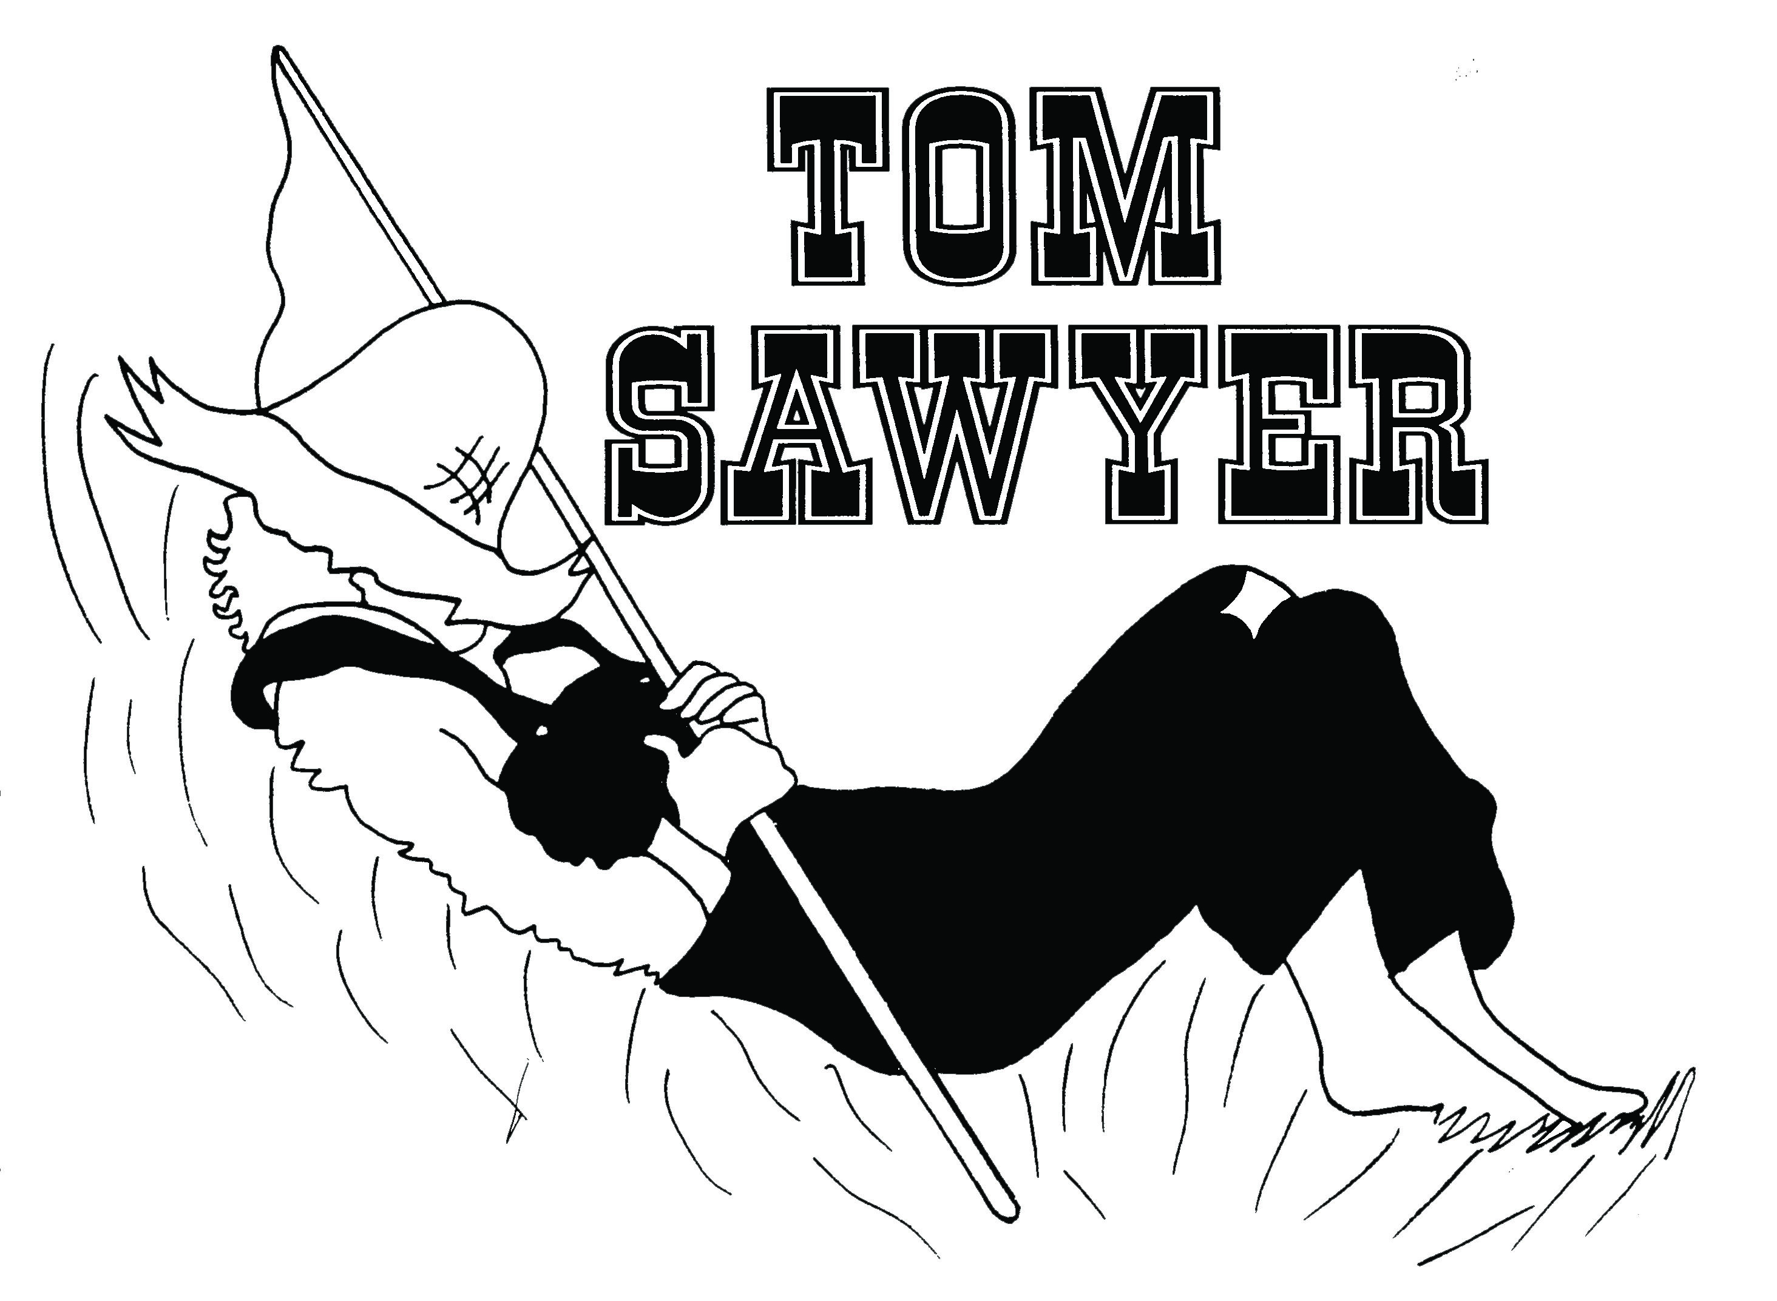  By Daniel Nordquist & Deborah Pick  (Performance time(s), date(s) and location)  Prairie Fire Children’s Theatre  and  (Sponsoring Organization)  Present

The Cast  Tom Sawyer  Huckleberry Finn  Becky Thatcher  Suzie Harper  Mrs. Thatcher  Mrs. Harper  Sidney  Hildegarde  Aunt Polly *  The Rightful King of France *  Townies  Townie #1  Townie #2  Townie #3  Townie #4  Townie #5  Townies –  Roger  River Rats  River Rat #1  River Rat #2  River Rat #3  River Rat #4  River Rat #5  River Rats –  *Indicates PFCT Actor/Director |  |  | Ghouls  Bats  The Scenes  Scene 1 ……………….……Who Put The Lizard In The Split Pea Soup?  Scene 2 ……………………………….……………..…………….Fence Murderin’  Scene 3 …………………………….…………….……Walkin’ In The Boneyard  Scene 4 ………………………….……….………………………………….……To Art!  Scene 5 ………………………..…………….……The Rightful King Of France  Scene 6 ………………………………….…………………..…The Treasure Map!  Scene 7 ………………………………………………………Tom Sawyer’s Gone!  Scene 8 …………………..…..……………..…Back From The Great Beyond  Scene 9 ……..………………………………………….………..Time For Plan “Z”  Scene 10 ….………………...………………………….….......Don’t Follow Me!  Scene 11 ………………………..………………….………….....Buried Treasure  Scene 12…………………..……………………………………………….…It’s Gone!  Scene 13……………………..…………………………..........The Plot Exposed!  Music Credits  Original songs by Daniel Nordquist and Deborah Pick  “Who Put The Lizard In The Split Pea Soup?”, “Walkin In The Boneyard”, “I Am The Rightful King Of France”,  “Tom Sawyer’s Gone...”

