Prairie Fire Children’s Theatre  Founded in 1987, Prairie Fire tours year-round to over 200 communities providing a week-long professional theatrical experience. Prairie Fire not only specializes in touring original adaptations of classic children’s tales, but also has a touring program for junior and high schools. In addition, Prairie Fire is available for theatrical workshops residencies. Prairie Fire is a proud recipient of the Minnesota Alliance of the Arts in Educational Programming.  For more information, contact:  Box 82, Barrett, MN 56311  Or (320) 528-2596  www.prairiefirechildrenstheatre.com  Acknowledgements  (An Opportunity for Thank You’s)  *No flash photos during performances, please!*  A photo session will follow each performance.  Thank you! |  |  | 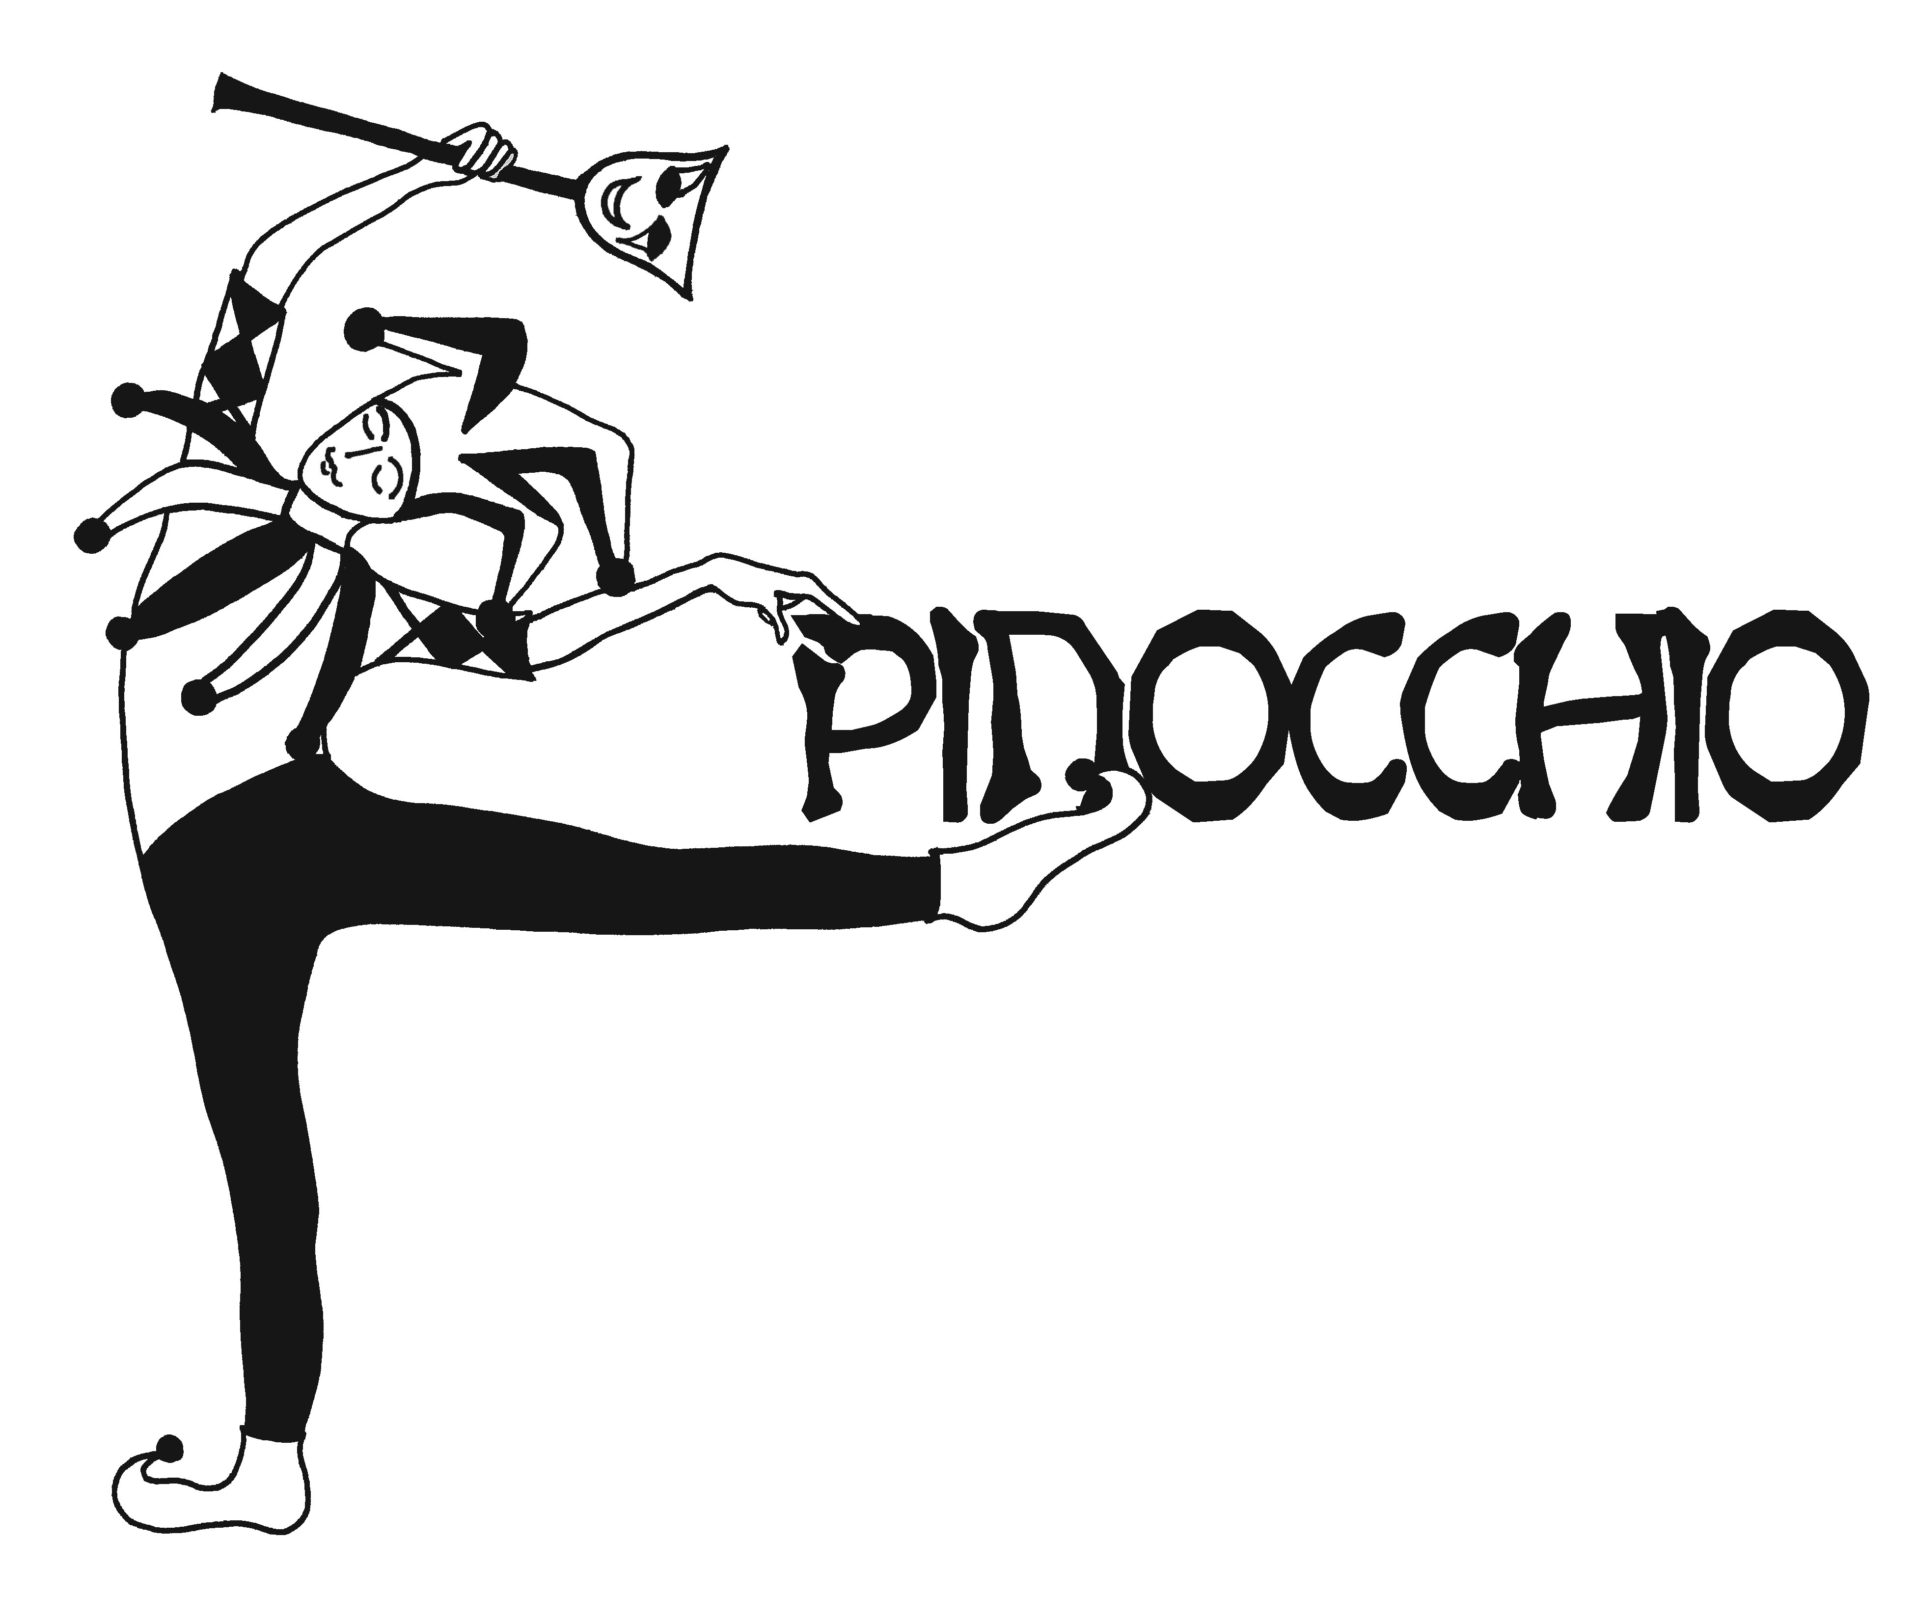  Script by Bob Gribas and Original Music by Angela Rinaldi  (Performance time(s), date(s) and location)  Prairie Fire Children’s Theatre  and  (Sponsoring Organization)  Present

The Cast  Pinocchio  Cricket  Blue Fairy  Spirits of the Forest -  Fox *  Gepetto / Tempesto *  Puppets  Arlecchino  Pantalone  Capitano  Isabella  Zanni  Puppets -  Vermin  Cat  Badger  Weasel  Ferret  Vermin –  Hooligans  Toni  Chaz  Spaz  Hooligans –  *Indicates PFCT Actor/Director |  |  | Townsfolk  Farmer  Constable  Judge  Mime  Paperboy  Waiter  Townsfolk -  The Scenes  Scene 1 …………………………….………….……..……The Enchanted Forest  Scene 2 ……………………………….……………….…….Gepetto’s Workshop  Scene 3 …………………………….…………………………………………The Town  Scene 4 ………………………….……….…….……………Gepetto’s Workshop  Scene 5 ………………………..……………...………….……….A Street In Town  Scene 6 ………………………………….…………….……..The Puppet Theatre  Scene 7 ……………………………………………………….…The Edge Of Town  Scene 8 …………………..…..………………………………….……………….A Field  Scene 9 ……..…………………………………………………………..……The Town  Scene 10 ….………………...…………..........................The Edge Of Town  Scene 11 ………………………..…………..………….......................The Town  Scene 12…………………..……………………………………………….….…A Farm  Scene 13……………………..……………………..…..........The Edge Of Town  Scene 14………..…………………..…………………………….….The Isle Of Fun  Scene 15……………..…….……………………………………………In The Whale  Scene 16…………………….……………………………….Gepetto’s Workshop  Music Credits  Original songs by Bob Gribas & Angela Rinaldi Gribas  “Vermin Brothers”, “Puppet Show”, “Show Business”,  “Field of Miracles”, “What You Deserve”, “Isle Of Fun”,  “Real Boy”, “Father & Son Celebration”  Other  The Beach Boys

