PRAIRIE FIRE CHILDREN’S THEATRE
And

PRESENT
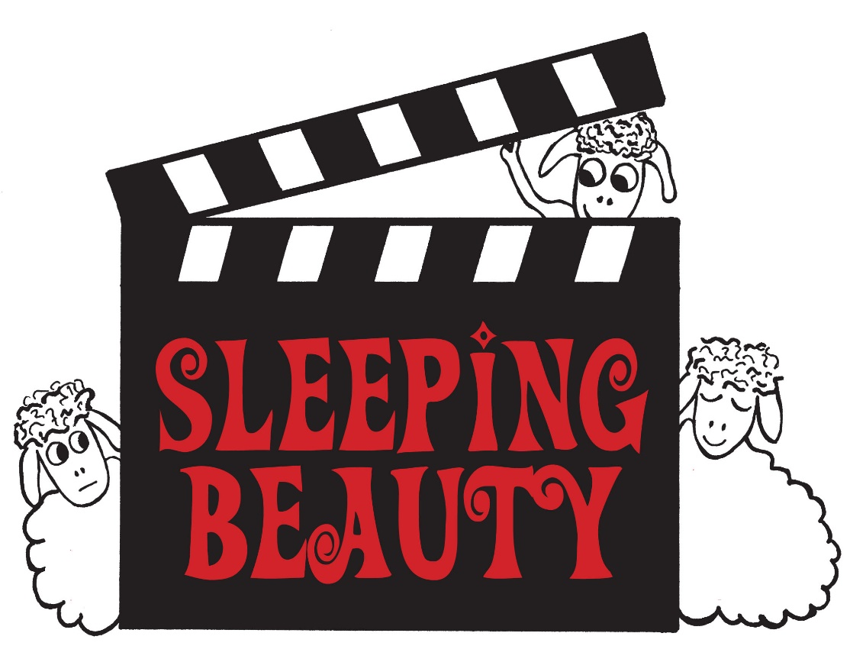

WHEN:

WHERE:

TICKET:

AUDITIONS:

