PRAIRIE FIRE CHILDREN’S THEATRE
and
(Sponsoring Organization)
PRESENT
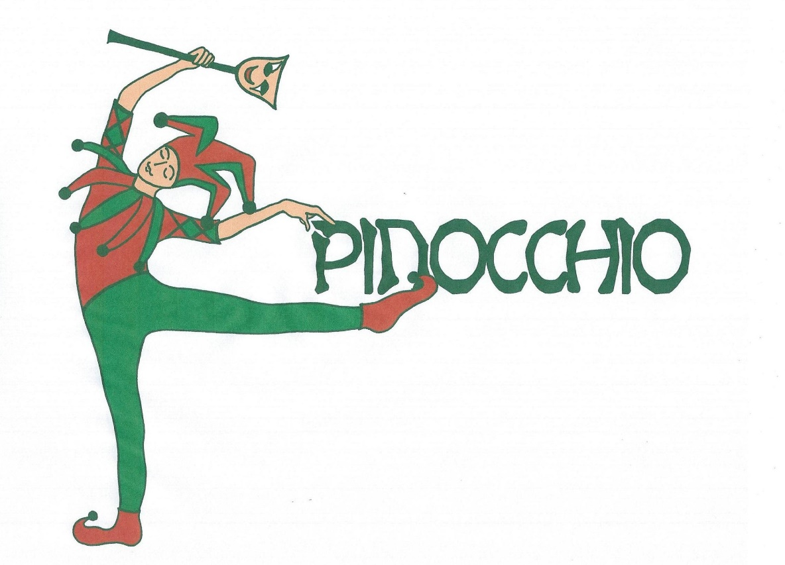
Script by Bob Gribas
Original Music by Angela Rinaldi Gribas

At:

Dates:

Times:

Ticket Prices:

For More Information:

