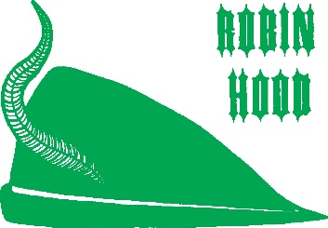
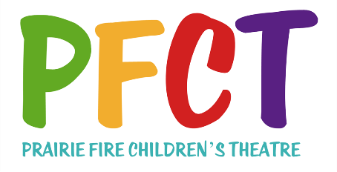
PRESS RELEASE – PERFORMANCES
FOR IMMEDIATE RELEASE

Date: _________________________

PRAIRIE FIRE CHILDREN’S THEATRE’S
“ROBIN HOOD”
ON STAGE THIS WEEKEND

(Your Community) - “HAHAHAHAHAHAHA!!!!!” The heaty laughter of Robin Hood and his Merry Band will sweep through the trees of Sherwood Forest (temporarily transplanted to (Performance Location) this weekend, as (# in cast) local children (and adults if applicable) take the stage along with two professional actors in Prairie Fire Children’s Theatre’s original musical production of “Robin Hood”.

Performances are slated for (days, dates, times) at (location) in (community.)

“Robin Hood,” with original script and music by Daniel Nordquist, continues Prairie Fire Children’s Theatre’s tradition of presenting classic tales as you’ve never seen. Though set traditionally in the 12th century, complete with Faeries and Gnomes, Prairie Fire’s version features the Sheriff of Nottingham as a man ahead of his time…way ahead…eight centuries ahead, in fact.

He is a visionary, and in his vision he see the trees of Sherwood Forest gone, and in their place stand “Sherwood Theme Park” and “The Mall of Nottingham.”

In his way stands the environmentally conscious outlaw, Robin Hood.

The local cast features: (Attach cast list, available from PFCT directors after Prairie Fire Theatre’s professionals (see bio) and (see bio) will co-direct the production and play the roles of Flora, The Queen of the Faeries and The Sheriff of Nottingham.

Tickets for the performance are (price) are available at (at the door or advance outlet)

“Robin Hood” features set and costume design by Deborah Pick.

This Prairie Fire Theatre residency is being sponsored by: (Sponsoring Organization).

Previous PFCT residences in (Community) have been (previous shows and years, if applicable).

For more information, contact: (local contact and phone number).

