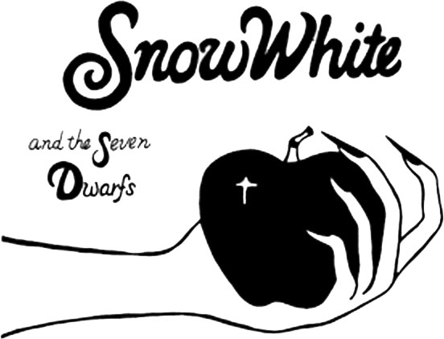
PRESS RELEASE – PERFORMANCE
FOR IMMEDIATE RELEASE
DATE:
“DOOBADOOBADOOBADOOBA, OH YEAH!!!”
Come join the fun as scores of local young actors take the stage this weekend with two professionals in Prairie Fire Children’s Theatre’s original musical production of the classic favorite “Snow White and the Seven Dwarfs”. Performances are at (times) on (days and dates) at (location) in (community).
The cast has been working all week to bring you a great show! Members include (list the cast as provided by your directors). Two professional actors will take the roles of the endearingly bumbling Huntsman and everyone’s favorite Evil Queen. (you may insert director biographies.)
The show promises to be fun for old and young alike, and continues Prairie Fire’s tradition of retelling the classics with a twist. Snow White is saved by the Prince, but not with a kiss! There is a great deal of music, including production numbers featuring The Townspeople and a lot of movement highlighted by the Queen’s Spellbinders and the Forest Creatures.
The performances are the culmination of a week-long residency by Prairie Fire Children’s Theatre sponsored by (sponsoring organization). Tickets are (prices and outlets if selling in advance). For more information contact (local phone number/website).

